Software Architecture Document
caArray

Last Revised: | January 24, 2008
Produced By: | NCICB Development Team
Version: | 1.0

Document Approvals
The list contains the name for the core project team and any key stakeholders who have an interest in the success of the project. An “S” identifies persons responsible for approval from the Business and Development. Sign off of the document would be required when a decision is made not to take action for defined gaps.

S | Name | Role | S | Name | Role
S | Anand Basu | CBIIT Engineering Manager | S | Juli Klemm, Ph.D. | CBIIT Product Manager
 | Brent Gendleman | Development Project Manager |  | George Komatsoluis, Ph. D. | CBIIT Independent QA Manager
 | Todd Parnell | Development Architect |  | Don Swan | NCICB Application Support
Revision History
When you make a change to a document, you must add an entry to this Revision History table and you must manually type the Last Revised Date on the front cover.

Date | Version | Description | Revised by
04/25/2007 | 0.1 | Initial draft, mostly template text with MAGE-OM design alternatives incorporated | Eric Tavela
05/15/2007 | 0.2 | Draft from Inception Iteration 1, containing basic architectural information for implemented candidate architecture. | Eric Tavela
05/22/2007 | 0.3 | Added additional content to complete draft for Inception Iteration 1. | Eric Tavela
09/25/2007 | 0.4 | Added complete content from Elaboration iterations 1 and 2:  Elaboration 1 Additions:  Addition of ArrayDataService, ArrayDesignService, and MAGE-TAB handling subsystems  Elaboration 2 Additions:  Addition of API (Grid and Java) subsystems  Incorporation of Struts 2 in UI Layer  Revisions based on model harmonization and API review sessions | Eric Tavela
09/26/2007 | 0.5 | Revisions based on review feedback:  Added diagram of central domain classes | Eric Tavela
10/3/2007 | 0.6 | Completed incorporation of review feedback:  Added CSM content  EVS integration
1/23/2008 | 0.7 | Revisions to incorporate changes through 2.0RC1  Synchronized Use Case descriptions  Revised UI layer discussion  Added discussion of object graph cutting  Added section on security using CSM4.0  Other revisions throughout document | Todd C. Parnell
1/24/2008 | 1.o | Synchronized diagrams to updated UML model – Finalized for 2.0 Release | Eric Tavela
Copyrights and Trademarks
© Copyright 2007-8 by CBIIT, caBIGTM. All rights reserved.
Table of Contents
1. Introduction 4
1.1. Purpose 4
1.2. Scope 4
1.3. Definitions, Acronyms, and Abbreviations 4
1.4. References 4
2. Architectural Representation 5
3. Architectural Goals and Constraints 5
3.1. caBIG Silver Compliance 5
3.2. Remote API Usability 5
3.3. High Performance Data Parsing, Storage and Retrieval 5
4. Use-Case View 6
4.1. Login 6
4.2. Manage Experiment Data Files 7
4.3. Validate Experiment Data Files 7
4.4. Import Experiment Data 7
4.5. Manage Array Designs 7
4.6. Manage Experiment Permissions 7
4.7. Acquire Experiment Data via API 7
5. Logical View 8
5.1. Overview 8
5.2. Architecturally Significant Design Elements 10
5.2.1. User Interface Layer 10
5.2.2. Grid API 11
5.2.3. Remote Java API 14
5.2.4. caArray Domain Classes 15
5.2.5. Access Control using CSM 4.0 19
5.2.6. ProjectManagementService 20
5.2.7. FileAccessService 22
5.2.8. FileManagementService 24
5.2.9. ArrayDataService 25
5.2.10. ArrayDesignService 27
5.2.11. MageTabParser 28
5.2.12. MageTabTranslation 29
5.2.13. CaArrayDataAccess 30
5.2.14. VocabularyService Subsystem 30
5.3. caarraydb 32
5.4. Use-Case Realizations 33
5.4.1. Manage Experiment Data Files 33
5.4.2. Import Data Files 34
5.4.3. Acquire Experiment Data via API 34
6. Implementation View 36
6.1. Overview 36
6.2. Artifacts 37
6.2.1. caarray.ear 37
6.2.2. caarray.war 37
6.2.3. caarray-ejb.jar 37
6.2.4. caarray-common.jar 37
6.2.5. caarray-client.jar 37
6.2.6. CaArraySvc-service.jar 37
7. Deployment View 37

Introduction

Purpose
This document provides a comprehensive architectural overview of the caArray system, using a number of different architectural views to depict different aspects of the system. It is intended to capture and convey the significant architectural decisions which have been made on the system.

Scope
This document describes the aspects of caArray’s design that are considered to be architecturally significant; that is, those elements and behaviors that are most fundamental for guiding the construction of caArray and for understanding caArray as a whole. Stakeholders who require a technical understanding of caArray are encouraged to start by reading this document, then reviewing the caArray UML model [CAARRAY_UML], and then by reviewing the source code. Please note that all diagrams represented in this document are taken from the caArray UML model [CAARRAY_UML]; for more detail about the elements in these diagrams, please consult the source model.

Definitions, Acronyms, and Abbreviations
- DAO – Data Access Object
- EJB – Enterprise JavaBeans
- J2EE – Java 2 Enterprise Edition
- Java SE – Java Standard Edition
- JDK – Java Development Kit
- JPA – Java Persistence API
- JSP – JavaServer Pages
- MAGE-OM – Microarray Gene Expression Object Model
- POJO – Plain Old Java Object
- RUP – Rational Unified Process
- UML – Unified Modeling Language

References
[CAARRAY _UML] caArray UML Models
//cm/caarray2/docs/analysis_and_design/models/caaray.eap
[CAARRAY _UCS] caArray Use Case Summary
//cm/caarray2/docs/analysis_and_design/models/caaray.eap
[KRUCHTEN] Philippe Kruchten 1995, "The 4+1 view model of architecture," IEEE Software. 12(6), November 1995.
//cm/caarray2/docs/analysis_and_design/references/architecture/Kruchten4+1.pdf
[RUP] The Rational Unified Process, Version 2003.06.13

Architectural Representation
The caArray architecture is represented in this document and in the UML design models as a set of views of the system from different but complementary perspectives. These views are:
- The Use-Case View – Describes the functional requirements of the system.
- The Logical View – Describes the organization of the system design into subsystems, interfaces, and classes and how these elements collaborate to provide the functionality described in the use-case view.
- The Process View - Illustrates the process decomposition of the system, including the mapping of classes and subsystems on to processes and threads.
- The Deployment View – Describes how the processes are allocated to hardware and execution environments and the communication paths between hardware nodes.
- The Implementation View – Describes the software components that realize the elements from the logical view and the dependencies between these components.
This style of describing software architecture is the approach recommended by the Rational Unified Process and is based on Philippe Kruchten’s work, “The 4+1 view model of architecture” [KRUCHTEN] and is refined in the Rational Unified Process [RUP].

Architectural Goals and Constraints
The following factors are key considerations beyond the functional requirements that are guiding the design of caArray 2.0.

caBIG Silver Compliance
caArray must be implemented in such a way that it may be certified caBIG Silver compliant. While Silver compliance is the requirement, caArray will provide a grid interface in anticipation of a possible move to Gold level compliance when the criteria for Gold compliance are established.

Remote API Usability
One of the major flaws in earlier releases of caArray has been the requirement to use the MAGE-OM to access annotation and data. Navigation between key classes in the MAGE is inefficient, difficult to understand, and difficult t0 implement. The object API exposed by the new evolution of caArray must be designed to be easily-understandable and navigable by remote clients, whether they access the API via the grid or a Java programmatic interface.

High Performance Data Parsing, Storage and Retrieval
Given that data storage and retrieval is the principal functionality of caArray, array data parsing, storage, and retrieval performance is key to a successful design.

Use-Case View
The use cases represented in Figure 1 below contain the functionality that have the greatest impact on the design of the caArray architecture. In brief, the use cases described below require implementation of mechanisms for security, validation, file management, data storage and retrieval, and API design. Brief descriptions of each of these use cases are provided below as extracted from the model. For information on the complete use-case model see the caArray Use-Case Summary [CAARRAY_UCS].
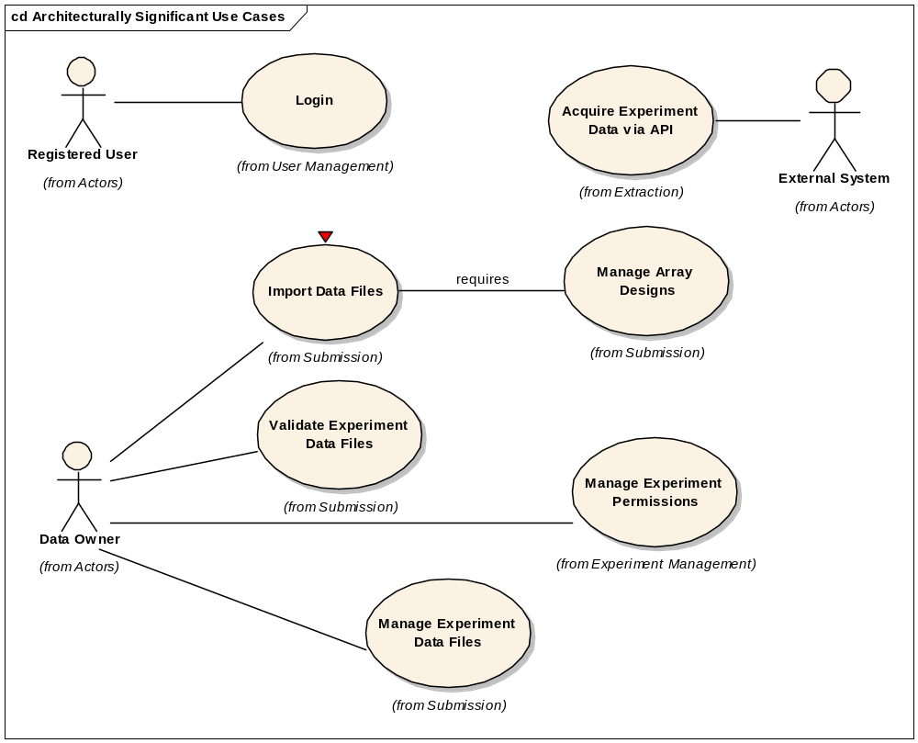
Figure 1 – Architecturally Significant Use Cases

Login
Initiated by any Registered User, this use case allows for the validation of the authenticity and authority of the given user either against a networked (LDAP) set of users or a local set (database). As a result of a successful login, the registered user is presented with their home space and the set of operations they have been granted privileges to perform.

Manage Experiment Data Files
Initiated by a Data Owner, this use case enables the uploading of annotation and array content collectively and independently into a caArray project and then provides the ability to validate, import and/or delete the uploaded files and records each action taken. Due to the large file size of array data and to a lesser extent – the annotation, the transfer of the file from the client to the server may take minutes or even hours to complete; so the ability to offer to run the upload in the background (allowing the user to perform other functions inside caArray) is desirable.

Validate Experiment Data Files
Initiated by a Data Owner, this use case allows for the validation of file structure and content for annotation or array data, with a future intent to import the data into the project. The content validation is not to determine the accuracy of the information from a scientific viewpoint; rather it is purely to ensure that the data files loaded are sound for importing into the system. This use case will also be invoked when a Data Owner chooses to import non-validated data.

Import Experiment Data
Initiated by a Data Owner, this use case enables the import of annotation and array data from previously uploaded or validated data and/or mage tab files.

Manage Array Designs
Initiated by a Curator, this use case allows for the uploading of array designs on an as needed basis. No array designs will be preloaded. This will support the flexibility for any particular organization to upload only the designs they use and reduce the overhead introduced by having to load unnecessary designs - which are often of significant size (100's of megabytes or more).

Manage Experiment Permissions
Initiated by a Data Owner, this use case allows for the promotion of a experiment's visibility. This action can apply to an entire project or to specific samples within the project. The basic visibility states of an experiment are: restricted, institution, group, public and collaborator. There is no restriction on changing a project's visibility, though it is not advisable once a publication has been published against the experiment.

Acquire Experiment Data via API
Initiated by an External System, this use case enables programmatic extraction of annotation and array content from caArray using an API. The use case also includes extraction of data from caArray by a grid client through a caGrid service. caBIG Analysis Services is the primary External System targeted and public and protected data should be available provided appropriate authorization is used. The use case may expand to include external systems such as GEO or Array Express or other systems that are local to the installer or NCICB that may have an interest in the data contained in caArray.

Logical View

Overview
The design model (from which the logical view is taken) is the most significant model, requiring the most effort and containing the majority of the content. Accordingly, the description of the logical view of caArray’s architecture will receive the most attention here. This section of the document first describes the structural hierarchy of the system in layers, packages, and subsystems and then goes on to describe how these elements collaborate to provide the most architecturally significant functionality. Figure 2 below shows the top-level structural organization of caArray. The major dependencies between subsystems are represented as well, though it should be noted that some supporting dependencies have been elided to enhance readability of the diagram.
The only subsystems that are accessible to external systems are the subsystems represented in the Grid API layer and the Remote Java API layer. All subsystems implemented in the Application Logic and Business Logic layer are internal to the application and do not expose remote interfaces. The User Interface layer is accessible to web clients via HTTPS.
caArray is implemented as a J2EE 1.4 application built on top of Java SE 5 (JDK version 1.5.0_10) employing the following core J2EE technologies:
- JSP 2.0
- Servlet 2.4
- JMS 1.1
- EJB 3.0.
Only EJB session and message-driven beans will be employed; persistence is being managed directly with Hibernate 3.2 rather than EJB’s persistence API (JPA). JPA provides no significant advantages over Hibernate at this point and Hibernate provides additional extended functionality not included in JPA.
Clients of caArray can be characterized as either web UI clients or API clients.
Each of the subsystems shown in Figure 2 is described briefly following the diagram. The functionality of each of these subsystems is described in Section 5.2 and the context of their use is given in Section 5.3 which documents the use-case realizations that employ these subsystems.
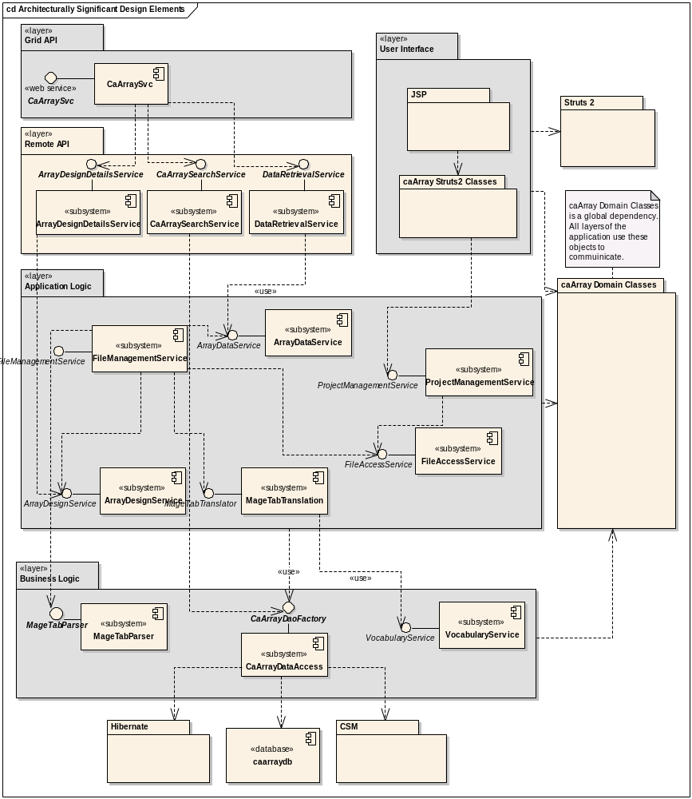

Figure 2 – Architecturally Significant Design Elements

Architecturally Significant Design Elements

User Interface Layer
The caArray user interface is accessed as a standard web application via HTTPS. It is implemented as a J2EE web application employing Struts 2 as the Model-View-Controller implementation. This layer provides presentation, navigation and validation functionality only. Validation logic at this level performs standard form based validation (e.g. checking for appropriate field formats) and is implemented using Strut2 2 validation. Furthermore, a bridge from Struts 2 validation to the Hibernate Validator framework was implemented that allows the definition of these constraints to come straight from the data model. This ensures that the UI will enforce the same constraints applied by the underlying storage mechanism. All application logic is implemented in the lower layers of caArray.
The pages presented to the web client use HTML and JavaScript only; no applets or other client-side component technologies are used. Many pages are dynamically updated based on user input without a complete page refresh using Ajax. This allows us to improve responsiveness, implement tabbed interfaces, and improve application usability. Ajax functionality is provided using the Prototype and Scriptaculous JavaScript libraries and the Ajaxtags tag library.
The User Interface layer also includes the login authentication classes CaArrayDBLoginModule and CaArrayDBLoginModule. These classes are used to integrate CSM authentication into the J2EE standard security model and allows for both database and LDAP based authentication. The classes and their relationships to authentication classes from CSM and the Java security API are shown in Figure 3 below.

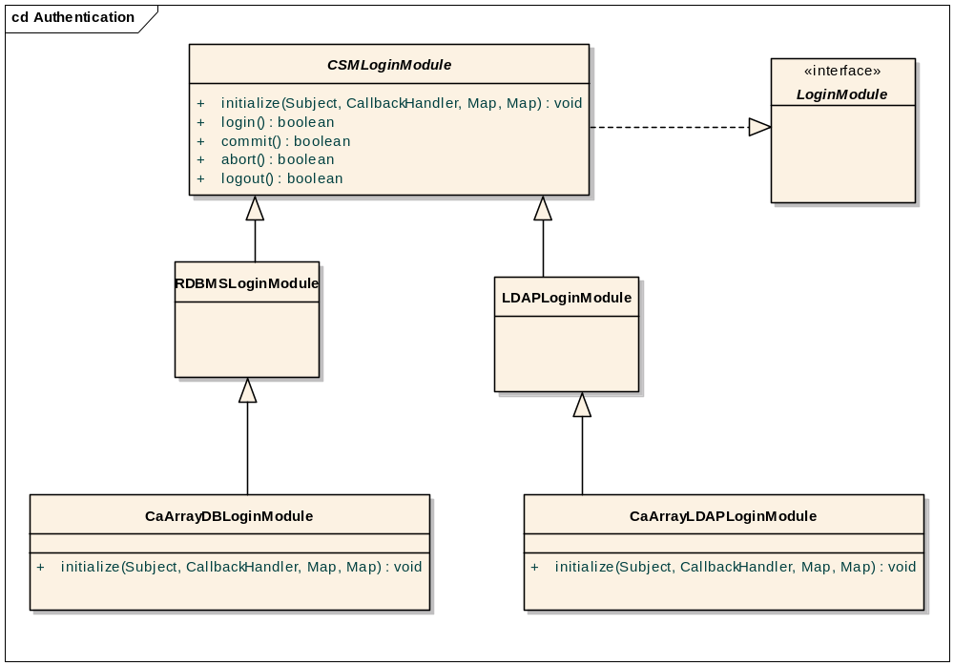
Figure 3—Authentication Classes

Grid API
The caArray Grid API is a Grid 1.1 compliant data service with several analytical services. The service was created via the Introduce Toolkit, and then modified to improve performance and add additional features. The service connects, via JNDI and RMI to a running instance of the caArray Remote Java API. The service connects to the web app at startup and uses the remote EJB API to service all requests received from the grid.
The grid service provides both the standard data query(CQLQuery) method and several analytic services. All data in caArray is available via the data service, but optimized data access is available via the analytic services. In particular, access to ArrayDesignDetails is best accomplished via the analytic services. This design choice was driven by the team’s experience with caArray 1.x.
To perform CQL searches, the service uses the API method List<AbstractCaAraryObject> search(CQLQuery) exposed by the CaArraySearchService EJB. After passing the CQLQuery to the EJB API, additional transformations are applied to generate a CQLQueryResults object for the grid client. The EJB search API performs the bulk of the work for grid clients. The search method accepts the CQLQuery object and returns matching objects from the domain model, ignoring any query modifiers in the original CQLQuery. caArray uses the CQL2HQL class provided by the core, which is immediately runnable in Hibernate.
Before any object or list of objects is returned, the server performs object graph cutting on the returned objects. This cutting prevents large, fully connected object graphs from being returned to clients and potentially overwhelming network, memory, or other resources. The graph cutting first initializes the root objects and all directly associated objects. Then, for each directly associated object, the associations from those objects to their directly associated objects are all set to null. As a result, remote clients, including the grid service itself, receive a limited set of data, and enough information about the dependent objects to continue to fill out the object graph to an arbitrary depth.
The grid service receives the list of matching domain objects from the search API and transforms those results into the CQLQueryResults expected by the grid client. To assist in this translation, caArray utilizes the CQLResultsCreationUtil from the SDK. Depending on query modifiers, the system either (1) translates whole objects, (2) translates [unique] specific properties, or (3) returns the count of objects in the list.
The Introduce generated components include all of the classes in Figure 4 below with the exception of CaArraySvcImpl and provide the standard marshalling and query functionality of a standard caGrid data service. Delegation to the Java Remote API is handled by the CaArraySvcImpl class which wraps access to the EJB remote session beans that expose array annotation and data retrieval functionality.
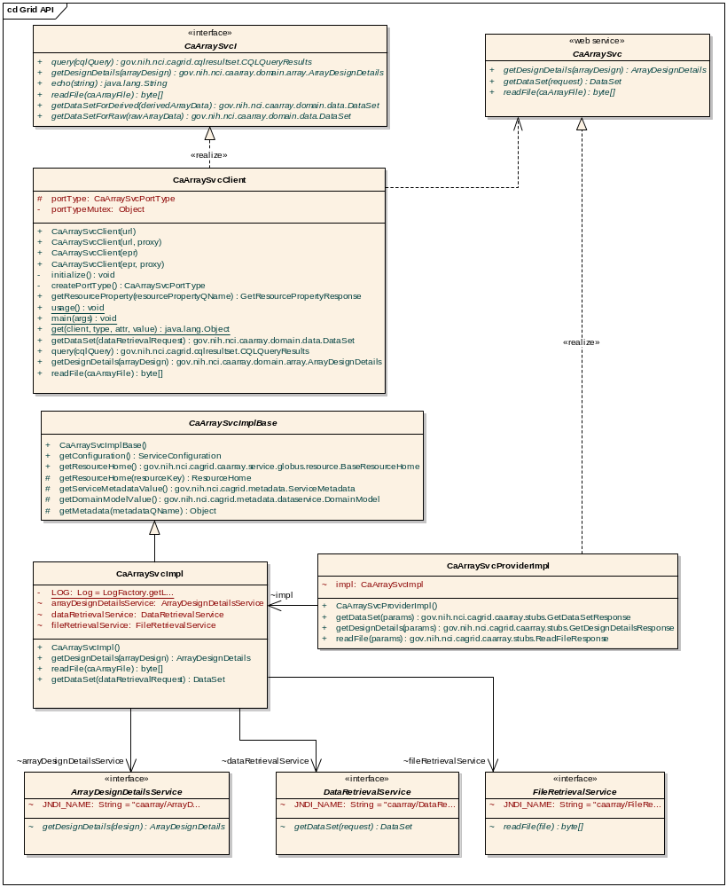
Figure 4 – CaArraySvc Grid API implementation

Remote Java API
The Remote Java API is implemented as a façade (the CaArrayServer class) representing a connection to caArray and a set of several stateless session EJBs with remote visibility. Clients instantiate a CaArrayServer instance, call the connect method and can then access the session EJB interfaces through accessor methods exposed by the CaArrayServer. These EJBs provide simplified, efficient access to caArray entities and data. Special consideration was given to the DataRetrievalService API to enable clients to retrieve only the data they require. Clients may select data for specific QuantitationTypes, Hybridizations, and AbstractDesignElements by configuring a DataRetrievalRequest object and passing it as an argument to the getDataSet() method. The remote interfaces and their exposed operations are shown in the class diagram provided below.
As discussed above, each remote Java API method performs object graph cutting to minimize data transmissions. The DataRetrievalService’s cutting is more sophisticated: instead of performing cutting at the child object level, all information about the DataSet is returned in a single request.
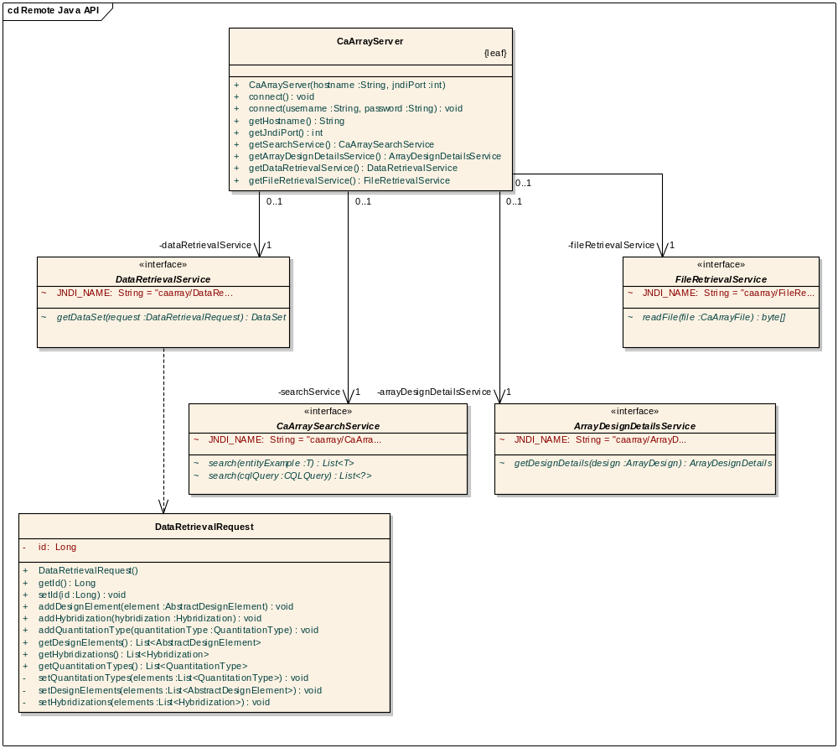
Figure 5—caArray Remote Java API

caArray Domain Classes
This section describes the classes used to model the microarray experiment and data that caArray is designed to manage. Since these classes are employed by all of the caArray subsystems and also must be understood by remote caArray clients (i.e. Java RMI clients.) Classes that represent important data constructs will be given detailed description here.
The underlying business object model is implemented as a set of POJOs that model the domain of microarray experiments and data. Whereas earlier versions of caArray used MAGE-OM 1.1 as the basis for the underlying object and data model, the new caArray implementation will be based on a completely revised, simplified object model. Although MAGE-OM is a published standard, there are significant disadvantages in using it as an underlying object model; it is complicated to understand, its complexity makes data storage inefficient, its structure does not permit useful object graph navigations, and many common relationships can not be stored when complete experiment annotation is not available. For these reasons we have chosen to produce a new, simplified object model for domain data representation. caCORE was used for the initial generation of these POJOs.
The domain classes are principally designed to support the entity model described by the MAGE-TAB 1.0 specification. The underlying object model described by MAGE-TAB is considerably more understandable than MAGE-OM while still providing a complete enough model to support MIAME compliance. The most central entities in the domain model are pictured in Figure 6.
Annotation for array design elements are represented by a hierarchy of annotation classes based on the array design type. Each array design element that reports on a biological sequence is related to an instance of AbstractProbeAnnotation. The hierarchy of annotation information is shown in Figure 8.
As has been noted earlier, array data needs to be represented in way that allows for efficient storage and transport when required by remote clients. The classes used to represent array data are shown in Figure 9. caArray is designed to represent array data at two levels:
- The AbstractArrayData hierarchy represents individual data files that have been imported into caArray, describing their type and relationships to hybridizations. These are high level representations that do not contain the actual data values.
- The DataSet class and the classes it is related to by composition (HybridizationData and the AbstractDataColumn hierarchy). These classes ultimately contain the array data values, specifically as arrays of primitive or String values within the AbstractDataColumn subclasses.
The DataSet classes are used both to persist the data contained in array data files and as a container for custom data sets requested by clients. As an example, a given Affymetrix CEL file imported into the system will have a single persistent DataSet containing a single persistent HybridizationData instance that contains several AbstractDataColumn instances (IntegerColumns for CELX and CELY, FloatColumn for CELIntensity, etc.). If a remote API client requests the data for all CEL files within an experiment a transient, compound DataSet is created that contains multiple HybridizationDatas where each HybridizationData is retrieved from persistent storage.
A columnar approach to data representation allows for efficient retrieval and storage when compared with a row-based representation. This represents a significant change from caArray 1.x where an entire BioDataCube must be retrieved in its entirety allowing for a significant reduction of network transfer overhead. This columnar approach is preferable for two reasons:
- Array data files typically contain relatively few columns but a large number of rows, typically in the tens of thousands or larger. When returning data to remote clients, it is far more efficient to serialize a large array of primitives when compared to returning a large object graph.
- Clients typically require only a small subset of the columns represented by an array data file, so organizing data by column allows for much more efficient custom DataSet assembly. Clients may indicate which columns to select by specifying QuantitationTypes to retrieve. The semantics of the various QuantitationTypes will be registered in caDSR in order to make them meaningful and comparable to clients that don’t have advance knowledge of the context of specific QuantitationTypes.
In addition to efficient storage and transfer, this approach is also intended meet the needs of caB2B and other tools that need everything navigable in the model (i.e. require the domain model semantics -- aren't aware of the data retrieval API). Making the columns themselves persistent with their data will allow these clients to navigate to the raw data values while we still retain an efficient mechanism for storage and retrieval (the columns' compressed, serialized value arrays are transparently expanded on request).
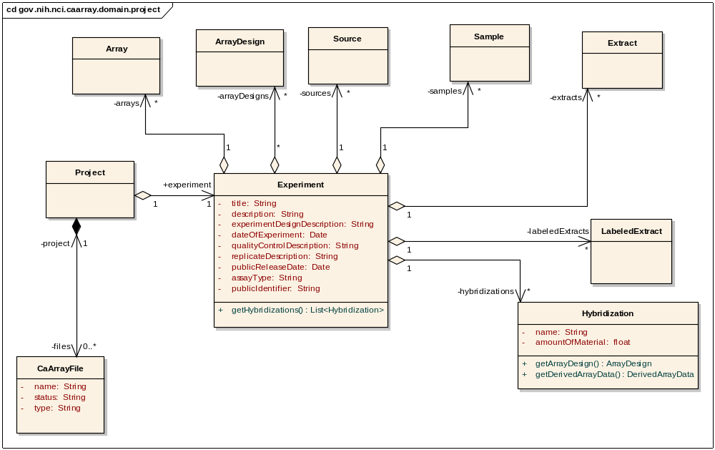
Figure 6—Experiment Overview

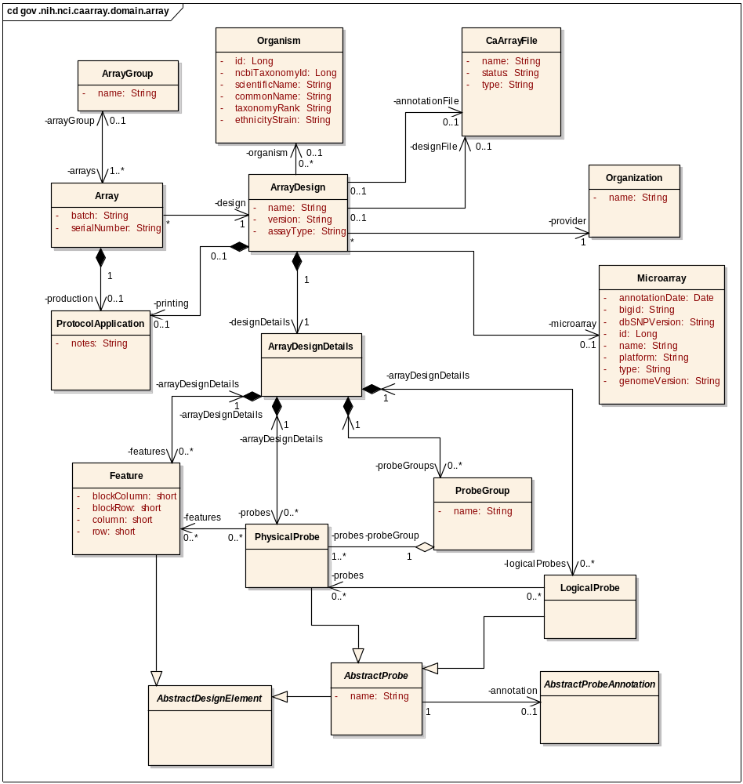
Figure 7 – caArray Array Design Classes
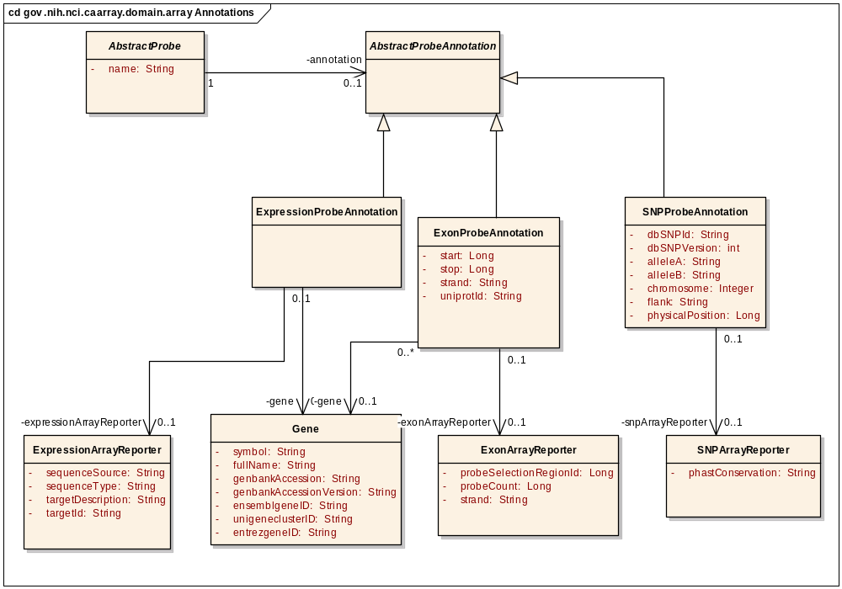
Figure 8 – caBIO Array Reporter Annotation Object Model
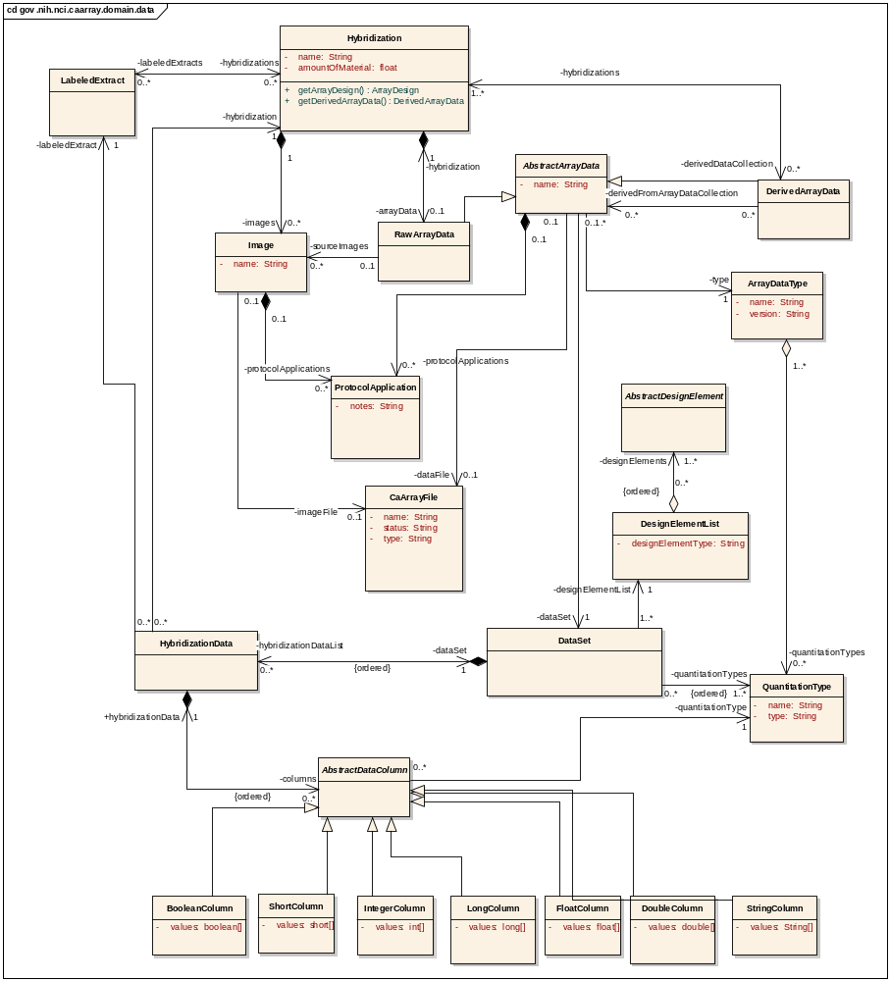
Figure 9—Array Data Classes

Access Control using CSM 4.0
caArray allows experiment owners to define fine grained access constraints on both whole experiments and individual samples (and the BioSources and Hybridization data derived from those samples). By default, non-experiment owners (including anonymous, non-logged in users) have access to a small set of overview information about an experiment. Read access to experiments and/or samples can be granted to the public as well as to defined groups of users (known as collaboration groups). The collaboration groups can also be granted write permissions to experiments and/or individual samples. Finally, an experiment can be removed from visibility entirely, making it completely inaccessible to users who have not been granted special permissions as described above.
This permissions system is implemented via integration with CSM 4.0. CSM provides a rich, fine grained domain model for expressing security constraints, including instance and attribute level security. The concepts described above map nicely onto the classes available in CSM in a very natural way. The architecturally interesting points about the integration, described below, involve synchronization between the caArray and CSM data models and the enforcement of the security constraints defined in the model.
Synchronizing the caArray and CSM data models requires creation and modification of CSM data structures expressing appropriate security constraints in response to corresponding operations on the caArray data model. This is accomplished via SecurityInterceptor, which takes advantage of a Hibernate API that allows application code to respond to Hibernate lifecycle events. SecurityInterceptor detects creation, modification and deletion of caArray domain objects and in response creates or modifies the CSM data structures which store security constraints on those objects.
Enforcement of the security constraints is done in two ways. Hibernate filters are used to enforce read permissions and visibility control for experiments. The filters are defined for any caArray domain classes which are covered by the security model, and act as essentially additional WHERE clauses that limit any queries against those classes to instances to which the user has access. These filters are applied transparently by Hibernate, and are automatically parameterized by CSM with the current user. This provides for a clean separation of concerns, as business logic can be written without the clutter of security considerations.
To enforce write permissions, we instead use the API provided by CSM's AuthorizationManager class. The logic for doing so is centralized in the SecurityUtils class.
It is important to note that security constraints are checked twice. First, during display of data, security constraints are checked to determine whether to display certain user interface elements. For instance, on the Work Queue page, the edit link will only be displayed for an experiment if the current user has write permissions to the experiment. Second, security constraints are checked and enforced before any actual operations against protected data are performed. This ensures that the user interface shows the user only the actions they have permissions to perform, but still enforces those permissions if a malicious user circumvents the normal user interface (for instance by URL hacking).

ProjectManagementService
The ProjectManagementService subsystem is implemented as a façade to allow the user interface to create and retrieve experiments. The implementation of this subsystem delegates directly to the CaArrayDataAccess service for entity management and to the FileAccessService for file management. The subsystem contents are shown in Figure 10 below.
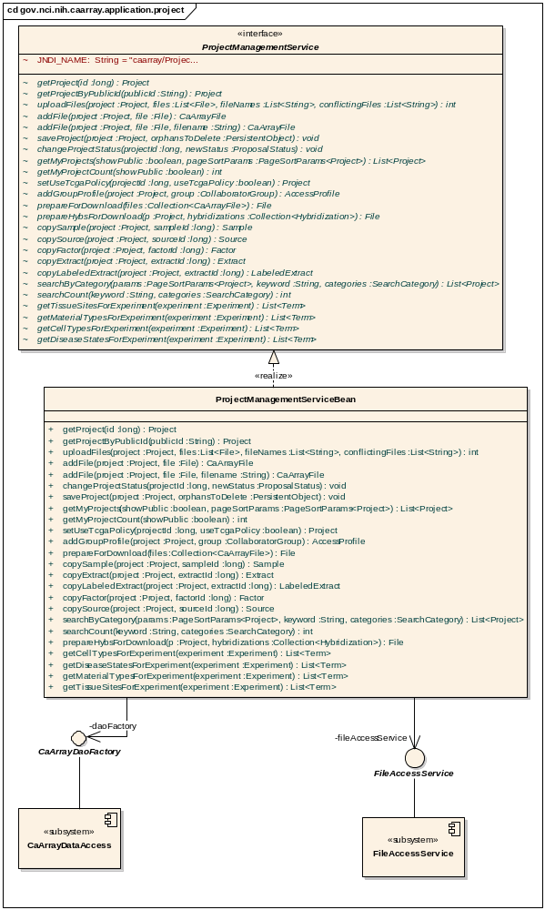
Figure 10 – ProjectManagementService Implementation

FileAccessService
The FileAccessService subsystem is implemented as a stateful session bean and is responsible for the storage of all files managed within caArray (annotation, array design and data). Files that are uploaded to caArray are registered with the FileAccessService which reads the files, compresses the contents and stores the contents as BLOB(s) (in the database) associated with a CaArrayFile instance. Due to limitations in MySQL when storing very large blobs (>250MB), caArray breaks very large files into multiple blobs for storage in the database. The storage of multiple blobs is transparent to users of the CaArrayFile class.
File retrieval is performed through the TemporaryFileCache interface. The implementation of this interface is stored in a ThreadLocal and maintains a Map of opened files so that any given client only needs to retrieve file contents from the database once per overall client transaction. Client subsystems that require access to file contents call the getFile(caArrayFile : CaArrayFile) : File method which performs the inverse operation; reading the contents from the BLOB(s), decompressing the contents and writing them to temporary file reading area. Clients are expected to call closeFile(file : File) when done using files so that the subsystem may remove the files from temporary file system storage, but the subsystem also performs clean up when it is finalized. The static structure of the FileAccessService subsystem is shown in Figure 11 and the act of storing file contents is shown in Figure 12.
This TemporaryFileCache implementation extracts each requested file to a different temporary location. This does mean potentially having duplicates of temporarily uncompressed files, but this should be the exception as files are only needed on download and when parsed. After weighing the potential approaches, the minor overhead of temporary duplicates was definitely preferable to the overhead of maintaining file reference counters across multiple sessions.
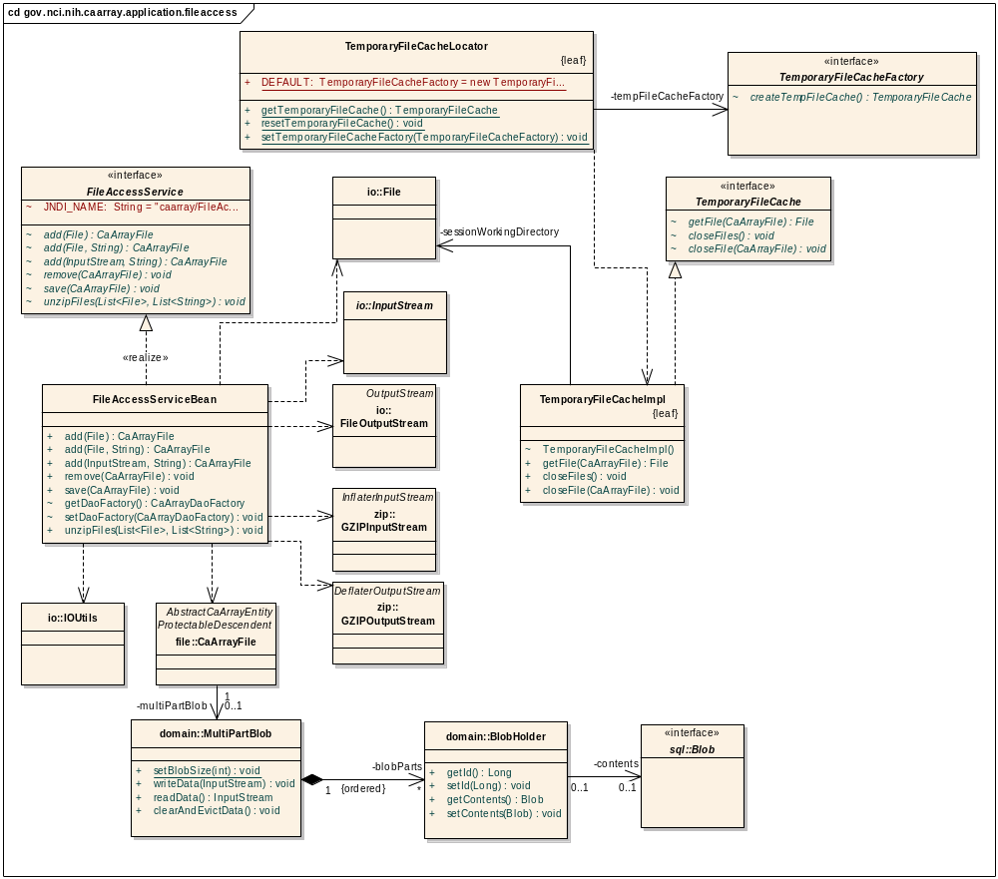
Figure 11 – FileAccessService Implementation Class Diagram
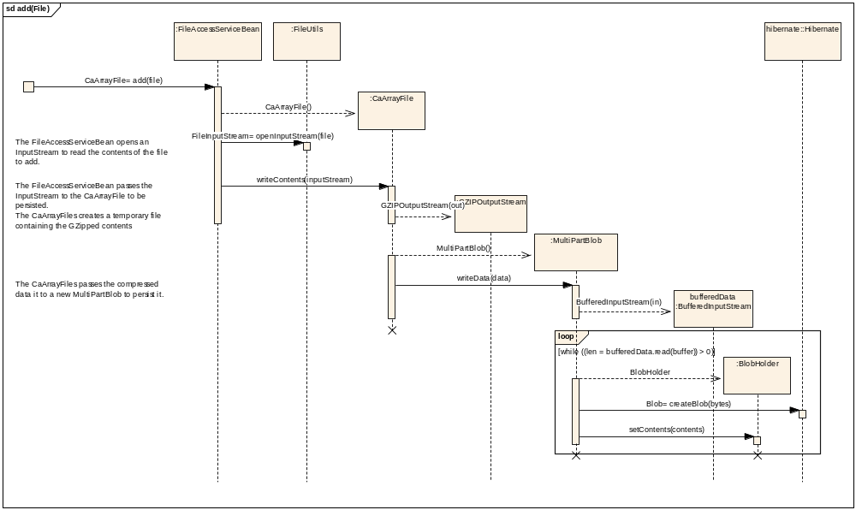
Figure 12 – Implementation of FileAccessService operation addFile(file : File)

FileManagementService
Whereas the FileAccessService handles the lower level functionality of file storage and retrieval, the FileManagementService subsystem is responsible for performing higher level logical file operations, specifically, the validation and import of MAGE-TAB annotation, array design files and array data files. The implementation of the subsystem does this through delegation to subsystems responsible for handling these various types of data. The organization of the FileManagementService implementation is shown in Figure 13 where the central bean delegates import and validation functionality to a set of importer classes that in turn delegate to the lower-level subsystems.
Validation results are instantiated by the lower-level subsystems and then the FileManagementService associates these with the CaArrayFile object that represents the validated annotation or data file.
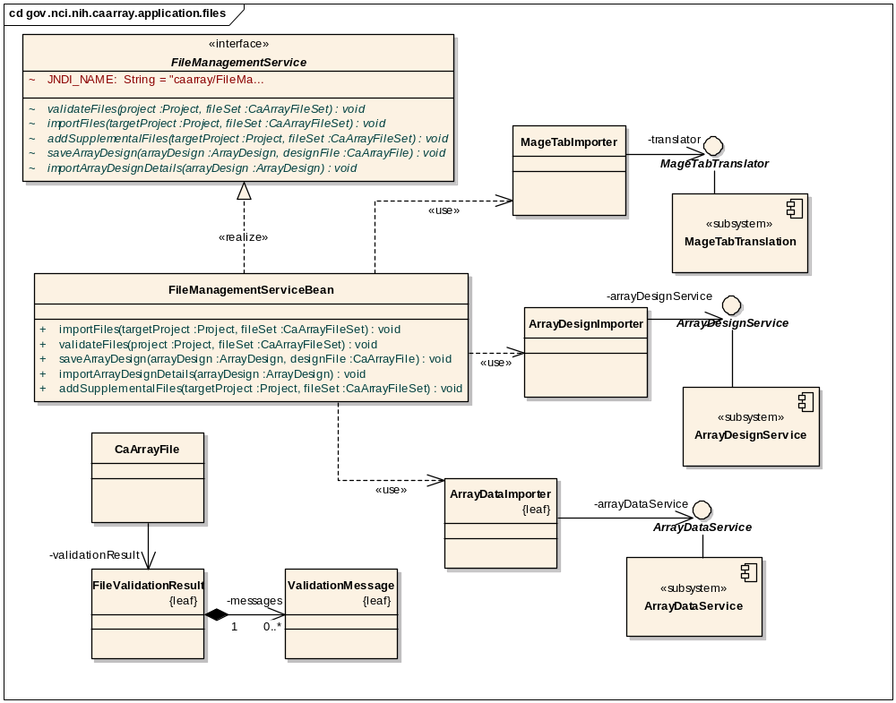
Figure 13—FileManagementService Implementation

ArrayDataService
The ArrayDataService subsystem is responsible for validating array data files, storing array data and retrieving array data when requested by clients. The typical order of events related to a given array data file is as follows:
- An array data file is validated using the validate(arrayDataFile : CaArrayDataFile) : ValidationResult operation. Only the generated FileValidationResult is created and persisted.
- The data file is imported using the import(arrayData : AbstractArrayData) : void operation. At this point, a DataSet and associated HybridizationData and AbstractDataColumn instances are created, but individual data values are not retrieved or persisted.
- A client requests data via the getData(arrayData : AbstractArrayData, types : List<QuantitationType>) : DataSet method. If this is the first request for the AbstractDataColumns associated with the provided QuantitationTypes, the requested data is parsed from the files as columnar arrays of primitives and stored persistently as serialized, GZipped byte[] representations of the arrays. The data is then returned to the client. If the data had previously been loaded as a result of earlier calls to getData the existing serialized byte[] is deserialized.
Though caArray 1.x and 2.0 do ultimately use the database to persist array data, the approaches are radically different. The 2.0 design does not exhibit the same performance and resource consumption when compared to 1.x. For illustration purposes, the 1.x design stores the array data from a file as a large number of rows (one per design element) with a column per data value, maintaining a complete relational representation of the entire data set. caArray 2.0 is using BLOB entry to store a large primitive array of data corresponding to a complete column's worth of data from a data file. For example, whereas a CEL file consumes hundreds of thousands of rows of seven columns apiece in 1.x, the new design will create 7 rows each with a single serialized, compressed representation of hundreds of thousands of data points.
The method import(arrayData : AbstractArrayData) : void is illustrated in Figure 14 below.
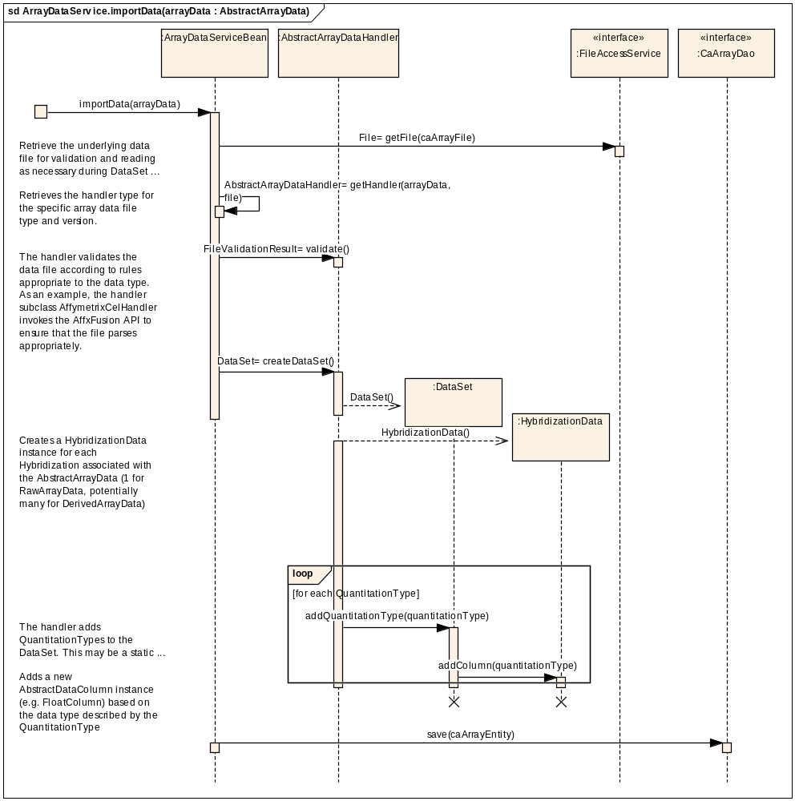
Figure 14—Import Operation Implementation

ArrayDesignService
The ArrayDesignService is responsible for parsing, persisting, and retrieving array design annotation from the various array annotation file types. In the implementation of the subsystem, each file format is handled by a specific subclass of AbstractArrayDesignHandler. These subclasses contain the logic to parse, validate, and persist the details of a given format. The array annotation is stored in the ArrayDesignDetails and caBIO reporter annotation structures described earlier in the section on the caArray Domain Classes package.
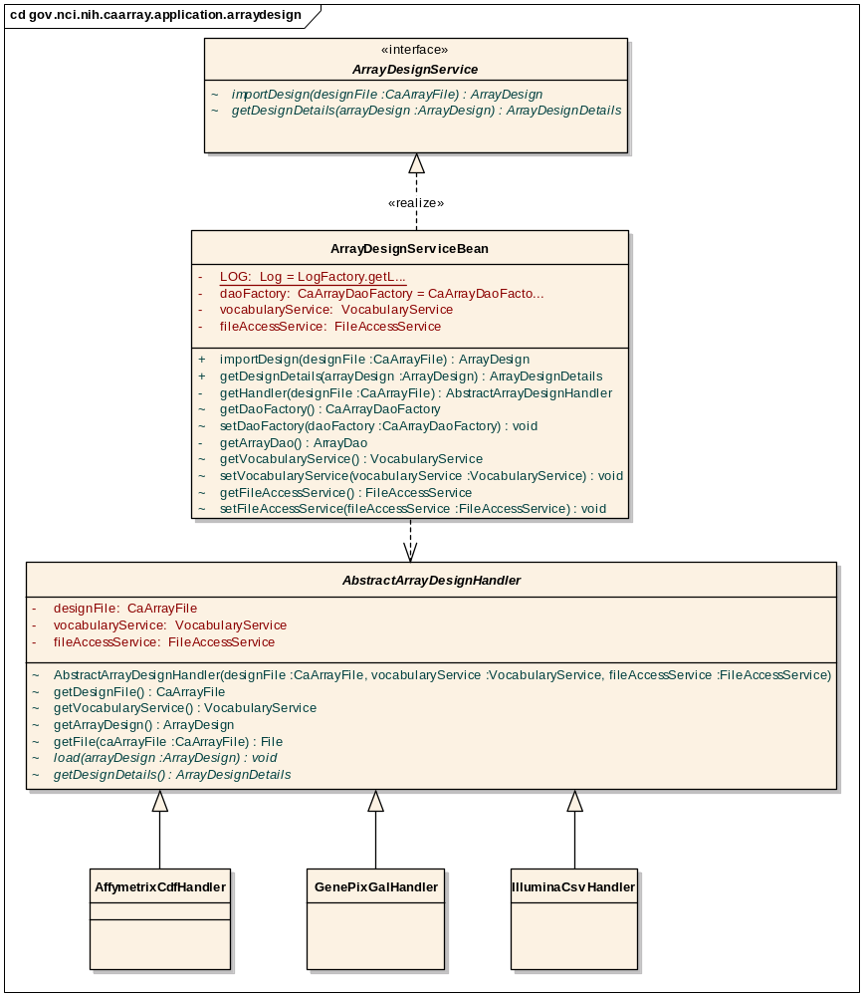
Figure 15—ArrayDesignService Subsystem Implementation

MageTabParser
The MageTabParser subsystem is responsible for reading a set of files in MAGE-TAB format, validating the files and ultimately representing the contents of the files in object model based on MAGE-TAB concepts. The major implementation classes are shown in Figure 16 below.
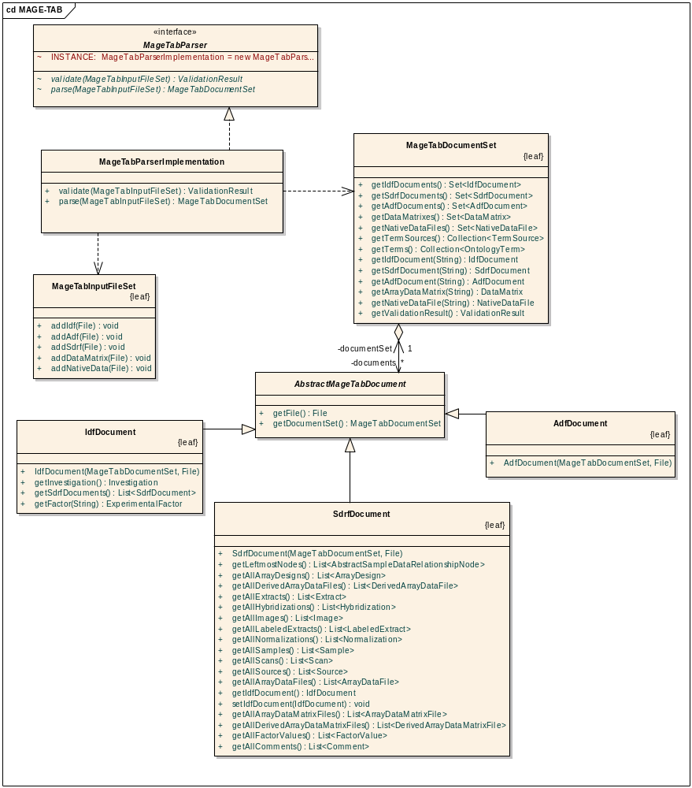
Figure 16—MageTabParser Subsystem Implementation

MageTabTranslation
The MageTabTranslation subsystem of caArray is invoked to translate from the MAGE-TAB object model generated by the MageTabParser system to a corollary caArray Domain Class representation. It implements a set of translator classes for each MAGE-TAB document type and for shared data types (i.e. Terms and TermSources).
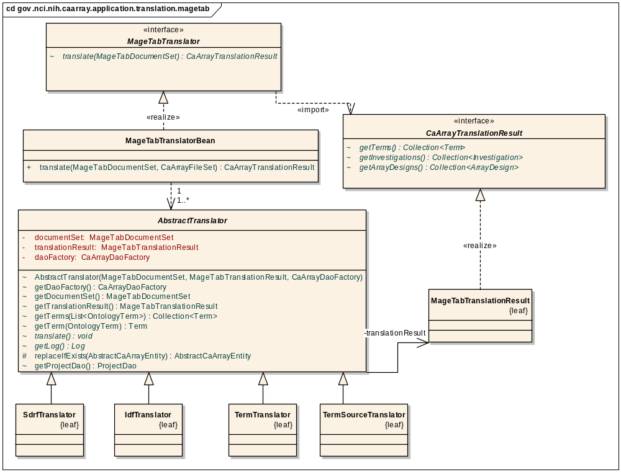
Figure 17—MageTabTranslator Subsystem Implementation

CaArrayDataAccess
caArray uses the standard Data Access Object pattern to provide data updates and retrievals. The DAOs are exposed as Java interfaces accessed through a Factory class. The implementations of the DAOs use Hibernate 3.2 as the underlying persistence mechanism.

VocabularyService Subsystem
The VocabularyService subsystem is implemented as a façade to allow the user interface to manage controlled vocabularies. The implementation of this subsystem delegates directly to the CaArrayDataAccess service for entity management. The data model accessed by this service represents a subset of concepts present in external vocabularies such as the MGED Ontology. These concepts provide a consistent Term and Category view of vocabularies, and allow the service to manage both locally and externally controlled vocabularies. However, at this time, external vocabularies are not communicated with directly. Instead, both local and external vocabularies are stored within the caArray database for maximum efficiency. The user interface and mage tab translation both access this service to store and retrieve terms as needed. The subsystem contents are shown in Figure 18.
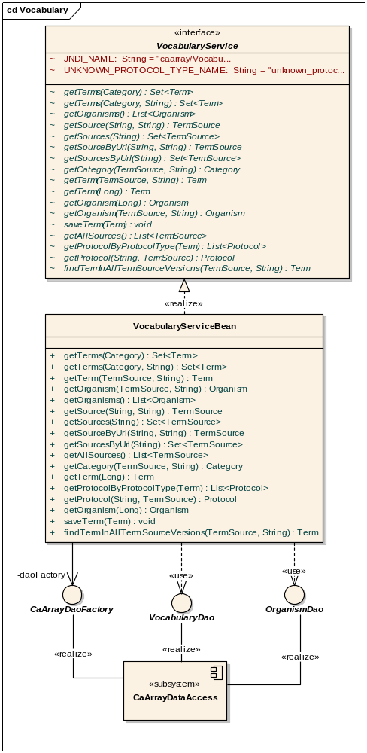
Figure 18 – VocabularyService Implementation

caarraydb
The caarraydb component represents the MySQL database schema that is used to store all of caArray’s persistent data. The schema is generated directly from Hibernate annotations recorded in the caArray Domain Classes so that the schema and domain classes are kept easily synchronized. caArray supports MySQL version 5.0 and uses InnoDB tables for transactional behavior.

Use-Case Realizations

Manage Experiment Data Files
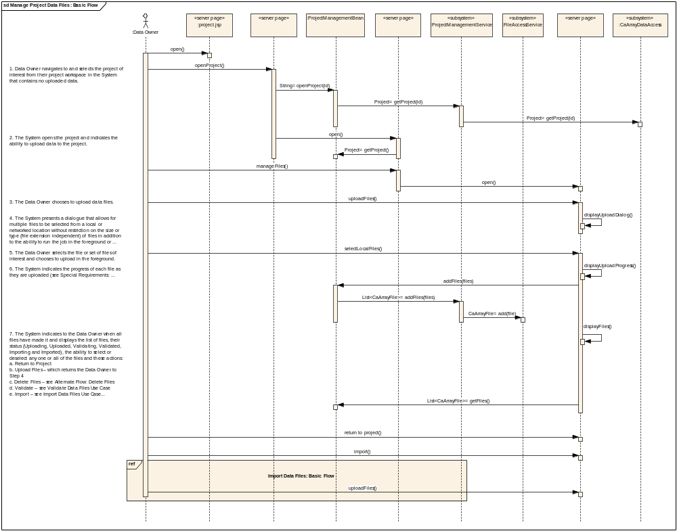
Figure 19—Manage Experiment Data Files Basic Flow Sequence Diagram

Import Data Files

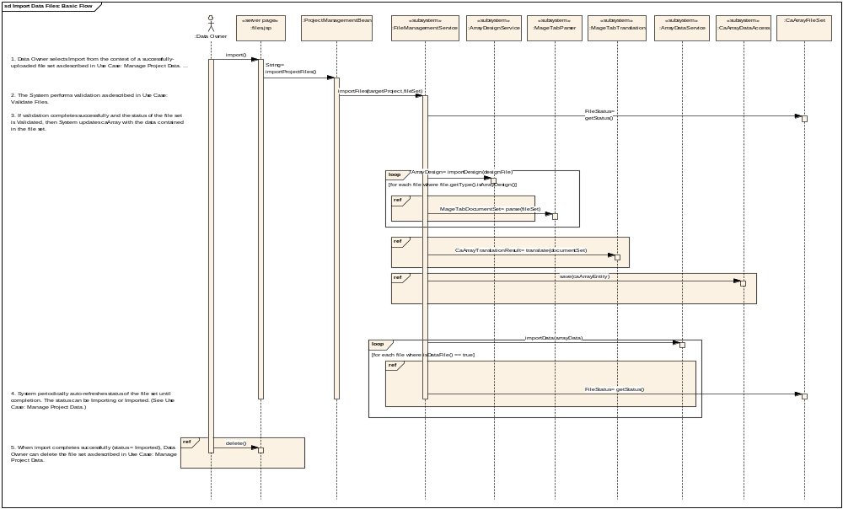
Figure 20—Import Data Files Basic Flow Sequence Diagram

Acquire Experiment Data via API

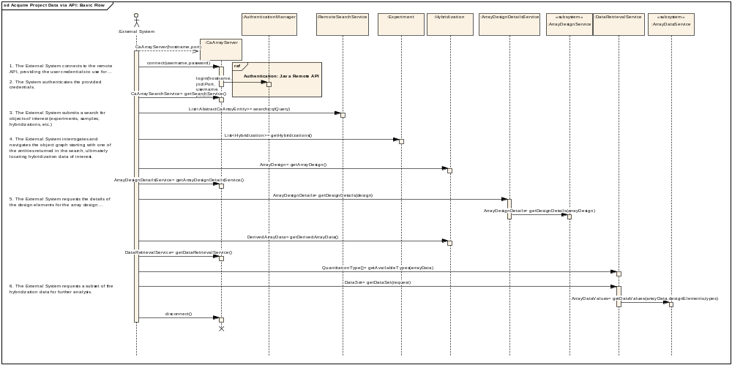
Figure 21—Acquire Experiment Data via API Basic Flow
Grid access follows a similar flow, with the CaArraySvc delegating calls to these same remote session beans.

Implementation View

Overview
Figure 22 below illustrates the major physical artifacts that comprise the caArray software deployment units. The major artifacts and their relationships to the subsystems they realize are described in Section 6.2.
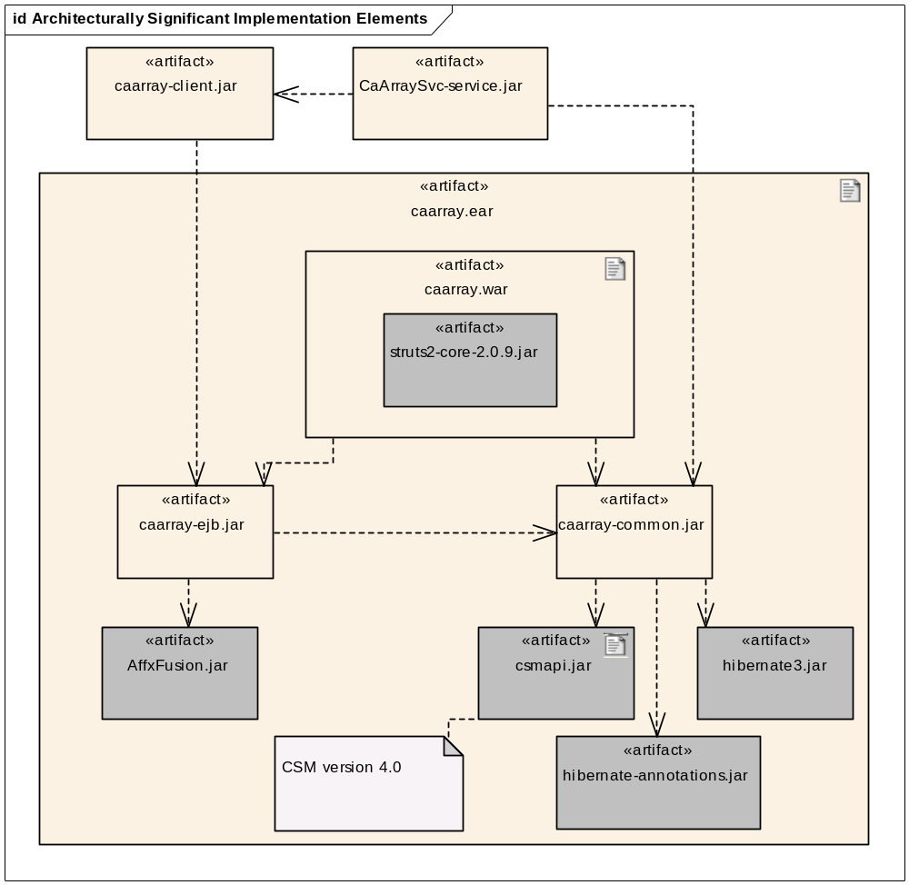
Figure 22—Architecturally Significant Implementation Elements

Artifacts

caarray.ear
The caarray.ear artifact is the J2EE Enterprise Application Archive (EAR) that contains all of the web portal application and EJB components that make up the User Interface, Remote Java API, Application Logic, and Business Logic layers of the application. The EAR also contains the third-party JARs necessary to support the Application and Business Logic Layers of the application.

caarray.war
The caarray.war artifact packages the JSPs and caArray Struts 2 classes that comprise the User Interface layer of caArray. The WAR also contains the Struts 2 third-party JARs and necessary supporting JARs.

caarray-ejb.jar
The caarray-ejb.jar packages the implementation of all of the EJB subsystems and the implementation of the remote API interfaces defined in caarray-client.jar. This includes all of the subsystems in the Application Layer and VocabularyService subsystem from the Business Logic Layer of the logical model. The important third-party dependency to note is the dependency on AffxFusion.jar which provides Affymetrix file format parsing support.

caarray-common.jar
The caarray-common.jar contains the caArray Domain Classes packages, the CaArray Data Access subsystem and the MageTabParser subsystem. The major third-party component dependencies noted are hibernate3.jar and hibernate-annotations.jar to support annotation-based Hibernate ORM mapping and to csmapi.jar to support entity access authorization.

caarray-client.jar
The caarray-client.jar contains the remote EJB interfaces required by Java Remote API clients and the caArray Grid Service. This JAR also repackages other third-party classes required by remote clients.

CaArraySvc-service.jar
The CaArraySvc-service.jar contains the caGrid API implementation classes.

Deployment View
The typical deployment configuration for caArray is documented in Figure 23. The NCICB deployment of caArray will be similar to the scenario modeled below with the addition of a front-end Apache web server that receives the HTTPS requests and then delegates these requests to the JBoss server where caArray is deployed. The JBoss container configures the datasource (for db connections) and SMTP information (for email).
While Globus is shown as the grid service execution environment, the NCICB deployment environment uses JBoss 4.0.4 as the container and Globus runs inside of JBoss 4.0.4. External adopters might also choose to deploy application components and execution environments to a single server.
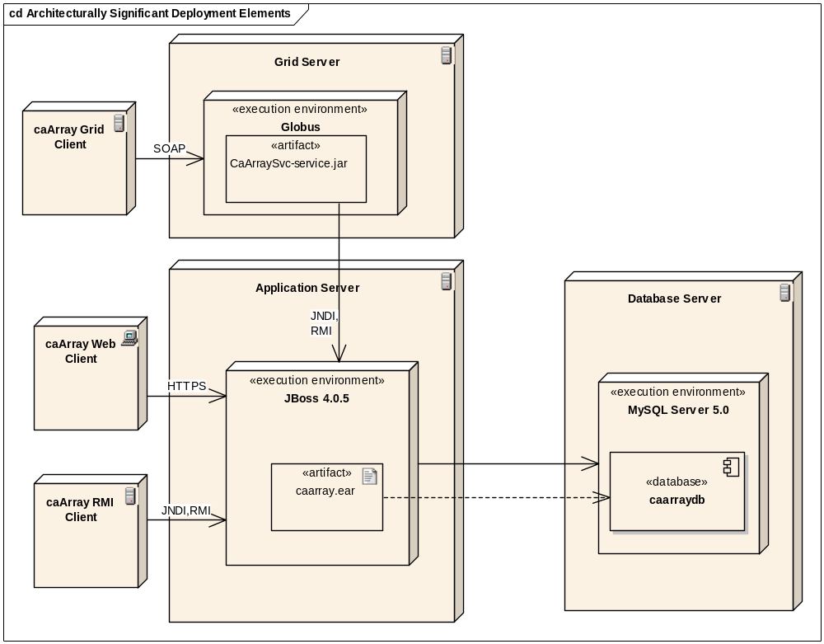
Figure 23 – Architecturally Significant Deployment Elements

Grid clients do not need the domain classes, since our domain model is registered in caDSR. However, grid clients that do use our domain classes can make user of our Castor XML mapping classes.
The delayed parsing of the data sets was deferred from the initial release of caArray 2.0. The data sets are stored as part of the import process. After delayed parsing is implemented, additional space savings will be achieved; only requested columns of data will be parsed and persisted. This is important since only a small subset of the quantitation types of a given data type are of interest to clients (for example, 2 columns out of 20 such as "detection' and "chip signal" of a .chp file in an Affymetrix experiment).

